**GIT ASSIGNMENTS:**

Install GIT and make sure it is added into PATH

**SECTION:0**

1. Create a directory 'project dir' & cd to 'project dir'.

2. Initialize git version database. (git init)

3. Create a new file Index.html.

4. Check the git status. You should find index.html as untracked file.

5. Stage the Index.html file.

6. Commit index.html

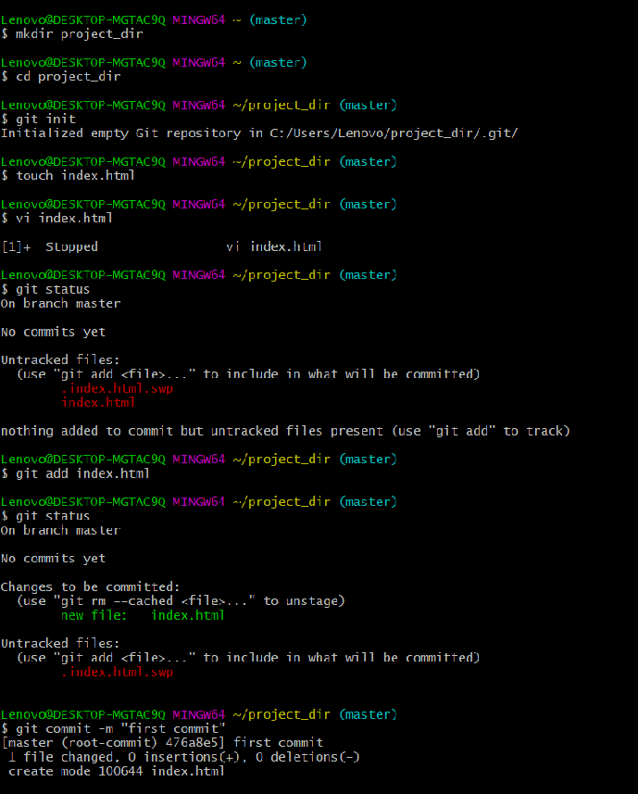

7. Make few changes in index.html & create a new file info.txt file.

8. Check git status. You should find index.html & info.txt

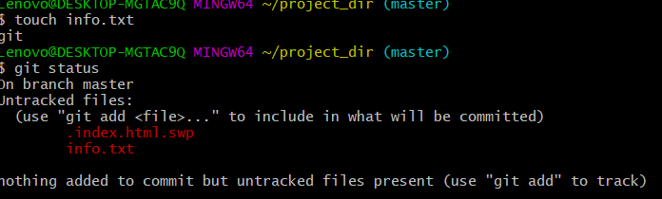

9. Configure GIT to ignore all txt files. untracked files.

10. Again check the git status. You should find only index.html as untracked

11. State & commit index.html

12. Log all your comments so far.

13. Make some changes in index.html.

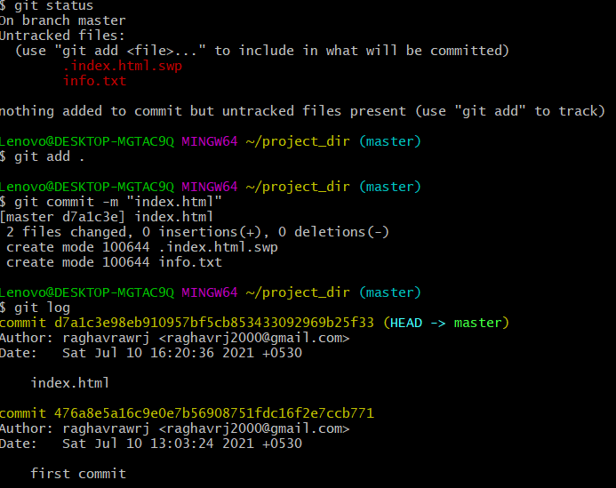

14. Revert the change made in the previous step using git command.

**git checkout –index.html**

15. Again change index.html.

16. Stage index.html

17. Revert back the last stage

**git add .**

**git status**

**git restore --staged index.html**

18. Rename 'add' command to 'my-add'.

19. Using my add command Stage index.html again & commit the changes.

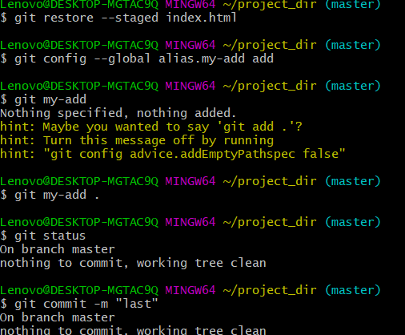

20. Revert the last commit.

**git checkout - -**

**SECTION :1🡪 GIT BRANCHING:**

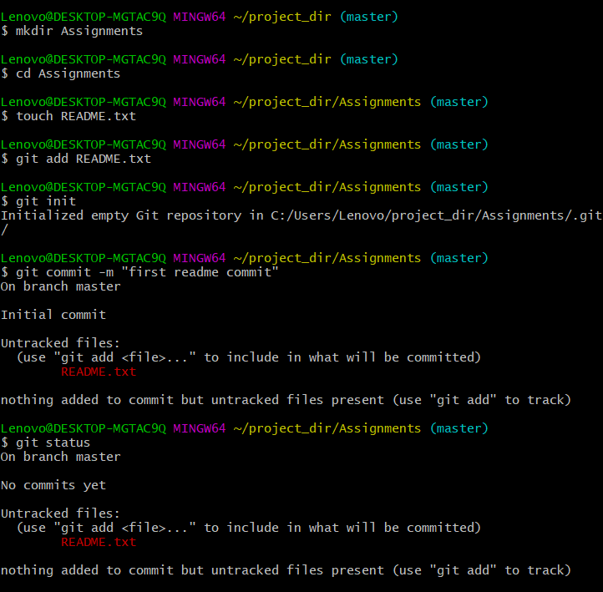

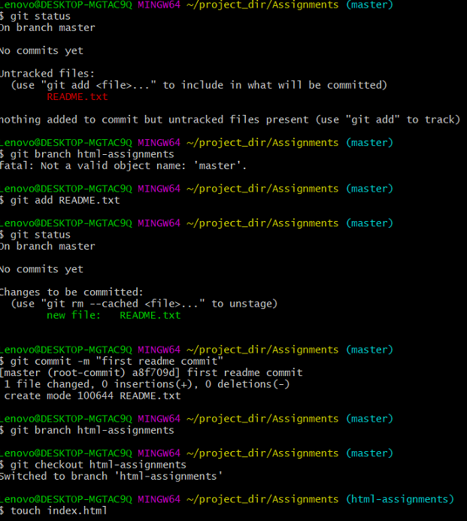

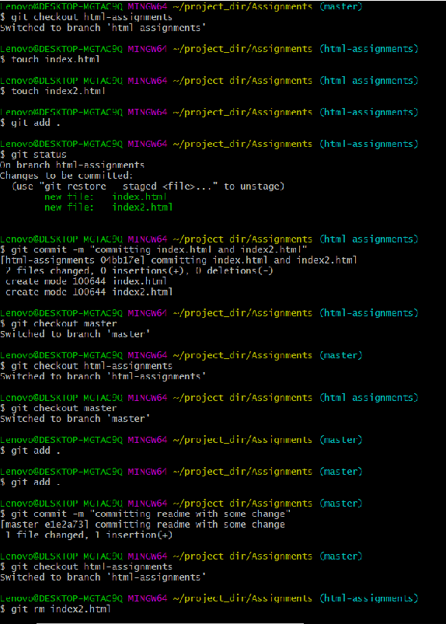

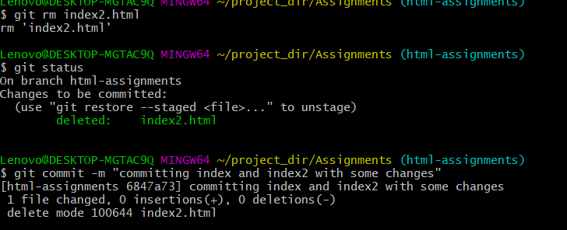

**Lines of Code**

Lenovo@DESKTOP-MGTAC9Q MINGW64 ~/project_dir (master)

$ mkdir Assignments

Lenovo@DESKTOP-MGTAC9Q MINGW64 ~/ project_dir (master)

$ cd Assignments

Lenovo@DESKTOP-MGTAC9Q MINGW64 ~/ project_dir (master)

$ touch README.txt

Lenovo@DESKTOP-MGTAC9Q MINGW64 ~/ project_dir (master)

$ git init

Initialized empty Git repository in C:/Users/Asus/test/Assignments/.git/

Lenovo@DESKTOP-MGTAC9Q MINGW64 ~/ project_dir /Assignments (master)

$ git config --global user.name 'MuskaanSingh09'

Lenovo@DESKTOP-MGTAC9Q MINGW64 ~/ project_dir /Assignments (master)

$ git config --global user.email 'singhmuskaan09@gmail.com'

Lenovo@DESKTOP-MGTAC9Q MINGW64 ~/ project_dir /Assignments (master)

$ git add README.txt

Lenovo@DESKTOP-MGTAC9Q MINGW64 ~/ project_dir /Assignments (master)

$ git commit -m 'Committed Readme.txt file'

[master (root-commit) e5f2127] Committed Readme.txt file

1 file changed, 0 insertions(+), 0 deletions(-)

create mode 100644 README.txt

Lenovo@DESKTOP-MGTAC9Q MINGW64 ~/ project_dir /Assignments (master)

$ git branch html-assignments

Lenovo@DESKTOP-MGTAC9Q MINGW64 ~/ project_dir /Assignments (master)

$ git checkout html-assignments

Switched to branch 'html-assignments'

Lenovo@DESKTOP-MGTAC9Q MINGW64 ~/ project_dir /Assignments (html-assignments)

$ touch H1.html

Lenovo@DESKTOP-MGTAC9Q MINGW64 ~/ project_dir /Assignments (html-assignments)

$ touch H2.html

Lenovo@DESKTOP-MGTAC9Q MINGW64 ~/ project_dir /Assignments (html-assignments)

$ git add H1.html H2.html

Lenovo@DESKTOP-MGTAC9Q MINGW64 ~/ project_dir /Assignments (html-assignments)

$ git commit -m 'H1 and H2 html assignments committed in html-assignments branch'

[html-assignments 62545ad] H1 and H2 html assignments committed in html-assignments branch

2 files changed, 0 insertions(+), 0 deletions(-)

create mode 100644 H1.html

create mode 100644 H2.html

Lenovo@DESKTOP-MGTAC9Q MINGW64 ~/ project_dir /Assignments (html-assignments)

$ git checkout --

Lenovo@DESKTOP-MGTAC9Q MINGW64 ~/ project_dir /Assignments (html-assignments)

$ git add H1.html

Lenovo@DESKTOP-MGTAC9Q MINGW64 ~/ project_dir /Assignments (html-assignments)

$ git commit -m 'H1 html file changed commit'

On branch html-assignments

nothing to commit, working tree clean

Lenovo@DESKTOP-MGTAC9Q MINGW64 ~/ project_dir /Assignments (html-assignments)

$ git checkout master

Switched to branch 'master'

Lenovo@DESKTOP-MGTAC9Q MINGW64 ~/ project_dir /Assignments (master)

$ git add README.txt

Lenovo@DESKTOP-MGTAC9Q MINGW64 ~/ project_dir /Assignments (master)

$ git commit -m 'Modified & committed README.txt'

On branch master

nothing to commit, working tree clean

Lenovo@DESKTOP-MGTAC9Q MINGW64 ~/ project_dir /Assignments (master)

$ git checkout html-assignments

Switched to branch 'html-assignments'

Lenovo@DESKTOP-MGTAC9Q MINGW64 ~/ project_dir /Assignments (html-assignments)

$ git add H1.html

Lenovo@DESKTOP-MGTAC9Q MINGW64 ~/ project_dir /Assignments (html-assignments)

$ git commit -m 'H1.html file changed and committed'

On branch html-assignments

nothing to commit, working tree clean

Lenovo@DESKTOP-MGTAC9Q MINGW64 ~/ project_dir /Assignments (html-assignments)

$ git add H2.html

Lenovo@DESKTOP-MGTAC9Q MINGW64 ~/ project_dir /Assignments (html-assignments)

$ git commit -m 'H2.html file changed and committed'

On branch html-assignments

Changes not staged for commit:

(use "git add <file>..." to update what will be committed)

(use "git restore <file>..." to discard changes in working directory)

modified: H1.html

modified: H2.html

modified: README.txt

no changes added to commit (use "git add" and/or "git commit -a")

Lenovo@DESKTOP-MGTAC9Q MINGW64 ~/ project_dir /Assignments (html-assignments)

$ git add H1.html

Lenovo@DESKTOP-MGTAC9Q MINGW64 ~/ project_dir /Assignments (html-assignments)

$ git commit -m 'H1.html file changed and committed'

[html-assignments f249ba7] H1.html file changed and committed

1 file changed, 9 insertions(+)

Lenovo@DESKTOP-MGTAC9Q MINGW64 ~/ project_dir /Assignments (html-assignments)

$ git add H2.html

Lenovo@DESKTOP-MGTAC9Q MINGW64 ~/ project_dir /Assignments (html-assignments)

$ git commit -m 'H2.html file changed and committed'

[html-assignments 2c3b595] H2.html file changed and committed

1 file changed, 9 insertions(+)

Lenovo@DESKTOP-MGTAC9Q MINGW64 ~/ project_dir /Assignments (html-assignments)

$ git checkout master

Switched to branch 'master'

M README.txt

Lenovo@DESKTOP-MGTAC9Q MINGW64 ~/ project_dir /Assignments (master)

$ git merge html-assignments

Updating e5f2127..2c3b595

Fast-forward

H1.html | 9 +++++++++

H2.html | 9 +++++++++

2 files changed, 18 insertions(+)

create mode 100644 H1.html

create mode 100644 H2.html

Lenovo@DESKTOP-MGTAC9Q MINGW64 ~/ project_dir /Assignments (master)

$ git branch -d html-assignments

Deleted branch html-assignments (was 2c3b595).

Lenovo@DESKTOP-MGTAC9Q MINGW64 ~/ project_dir /Assignments (master)

$ git status

On branch master

Changes not staged for commit:

(use "git add <file>..." to update what will be committed)

(use "git restore <file>..." to discard changes in working directory)

modified: README.txt

no changes added to commit (use "git add" and/or "git commit -a")

**SECTION:2🡪 CSS Assignments:**

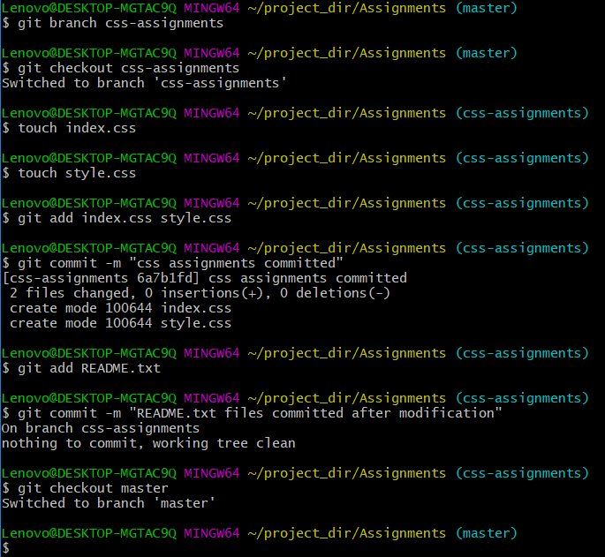

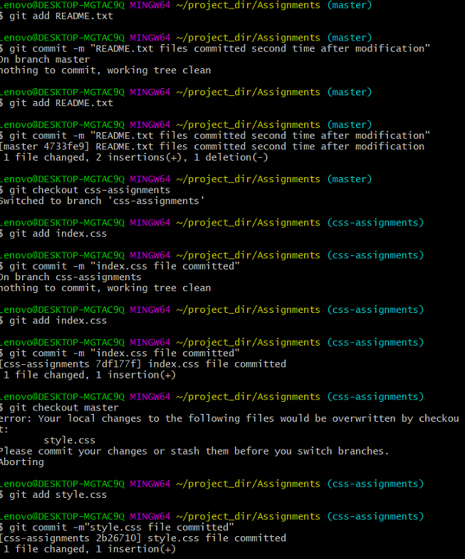

Lenovo@DESKTOP-MGTAC9Q MINGW64 ~/project_dir/Assignments (html-assignments)

$ git checkout master

Switched to branch 'master'

Lenovo@DESKTOP-MGTAC9Q MINGW64 ~/project_dir/Assignments (master)

$ git branch css-assignments

Lenovo@DESKTOP-MGTAC9Q MINGW64 ~/project_dir/Assignments (master)

$ git checkout css-assignments

Switched to branch 'css-assignments'

Lenovo@DESKTOP-MGTAC9Q MINGW64 ~/project_dir/Assignments (css-assignments)

$ touch index.css

Lenovo@DESKTOP-MGTAC9Q MINGW64 ~/project_dir/Assignments (css-assignments)

$ touch style.css

Lenovo@DESKTOP-MGTAC9Q MINGW64 ~/project_dir/Assignments (css-assignments)

$ git add index.css style.css

Lenovo@DESKTOP-MGTAC9Q MINGW64 ~/project_dir/Assignments (css-assignments)

$ git commit -m "css assignments committed"

[css-assignments 6a7b1fd] css assignments committed

2 files changed, 0 insertions(+), 0 deletions(-)

create mode 100644 index.css

create mode 100644 style.css

Lenovo@DESKTOP-MGTAC9Q MINGW64 ~/project_dir/Assignments (css-assignments)

$ git add README.txt

Lenovo@DESKTOP-MGTAC9Q MINGW64 ~/project_dir/Assignments (css-assignments)

$ git commit -m "README.txt files committed after modification"

On branch css-assignments

nothing to commit, working tree clean

Lenovo@DESKTOP-MGTAC9Q MINGW64 ~/project_dir/Assignments (css-assignments)

$ git checkout master

Switched to branch 'master'

Lenovo@DESKTOP-MGTAC9Q MINGW64 ~/project_dir/Assignments (master)

$ git add README.txt

Lenovo@DESKTOP-MGTAC9Q MINGW64 ~/project_dir/Assignments (master)

$ git commit -m "README.txt files committed second time after modification"

On branch master

nothing to commit, working tree clean

Lenovo@DESKTOP-MGTAC9Q MINGW64 ~/project_dir/Assignments (master)

$ git add README.txt

Lenovo@DESKTOP-MGTAC9Q MINGW64 ~/project_dir/Assignments (master)

$ git commit -m "README.txt files committed second time after modification"

[master 4733fe9] README.txt files committed second time after modification

1 file changed, 2 insertions(+), 1 deletion(-)

Lenovo@DESKTOP-MGTAC9Q MINGW64 ~/project_dir/Assignments (master)

$ git checkout css-assignments

Switched to branch 'css-assignments'

Lenovo@DESKTOP-MGTAC9Q MINGW64 ~/project_dir/Assignments (css-assignments)

$ git add index.css

Lenovo@DESKTOP-MGTAC9Q MINGW64 ~/project_dir/Assignments (css-assignments)

$ git commit -m "index.css file committed"

On branch css-assignments

nothing to commit, working tree clean

Lenovo@DESKTOP-MGTAC9Q MINGW64 ~/project_dir/Assignments (css-assignments)

$ git add index.css

Lenovo@DESKTOP-MGTAC9Q MINGW64 ~/project_dir/Assignments (css-assignments)

$ git commit -m "index.css file committed"

[css-assignments 7df177f] index.css file committed

1 file changed, 1 insertion(+)

Lenovo@DESKTOP-MGTAC9Q MINGW64 ~/project_dir/Assignments (css-assignments)

$ git checkout master

error: Your local changes to the following files would be overwritten by checkout:

style.css

Please commit your changes or stash them before you switch branches.

Aborting

Lenovo@DESKTOP-MGTAC9Q MINGW64 ~/project_dir/Assignments (css-assignments)

$ git add style.css

Lenovo@DESKTOP-MGTAC9Q MINGW64 ~/project_dir/Assignments (css-assignments)

$ git commit -m"style.css file committed"

[css-assignments 2b26710] style.css file committed

1 file changed, 1 insertion(+)

Lenovo@DESKTOP-MGTAC9Q MINGW64 ~/project_dir/Assignments (css-assignments)

$ git checkout master

Switched to branch 'master'

Lenovo@DESKTOP-MGTAC9Q MINGW64 ~/project_dir/Assignments (master)

$ git merge css-assignments

Merge made by the 'recursive' strategy.

index.css | 1 +

style.css | 1 +

2 files changed, 2 insertions(+)

create mode 100644 index.css

create mode 100644 style.css

Lenovo@DESKTOP-MGTAC9Q MINGW64 ~/project_dir/Assignments (master)

$ git branch -d css.assignments

error: branch 'css.assignments' not found.

Lenovo@DESKTOP-MGTAC9Q MINGW64 ~/project_dir/Assignments (master)

$ git branch -d css-assignments

Deleted branch css-assignments (was 2b26710).

Lenovo@DESKTOP-MGTAC9Q MINGW64 ~/project_dir/Assignments (master)

$

**SECTION:3🡪 JavaScript Assignments:**

Lenovo@DESKTOP-MGTAC9Q MINGW64 ~/project_dir/Assignments (master)

$ git branch js-assignments

Lenovo@DESKTOP-MGTAC9Q MINGW64 ~/project_dir/Assignments (master)

$ git checkout js-assignments

Switched to branch 'js-assignments'

Lenovo@DESKTOP-MGTAC9Q MINGW64 ~/project_dir/Assignments (js-assignments)

$ touch J1.js

Lenovo@DESKTOP-MGTAC9Q MINGW64 ~/project_dir/Assignments (js-assignments)

$ touch J2.js

Lenovo@DESKTOP-MGTAC9Q MINGW64 ~/project_dir/Assignments (js-assignments)

$ git add J1.js J2.js

Lenovo@DESKTOP-MGTAC9Q MINGW64 ~/project_dir/Assignments (js-assignments)

$ git commit -m "JS assignments committed"

[js-assignments e75b4ae] JS assignments committed

2 files changed, 0 insertions(+), 0 deletions(-)

create mode 100644 J1.js

create mode 100644 J2.js

Lenovo@DESKTOP-MGTAC9Q MINGW64 ~/project_dir/Assignments (js-assignments)

$ git add README.txt

Lenovo@DESKTOP-MGTAC9Q MINGW64 ~/project_dir/Assignments (js-assignments)

$ git commit -m "README.txt files gets committed"

On branch js-assignments

nothing to commit, working tree clean

Lenovo@DESKTOP-MGTAC9Q MINGW64 ~/project_dir/Assignments (js-assignments)

$ git add README.txt

Lenovo@DESKTOP-MGTAC9Q MINGW64 ~/project_dir/Assignments (js-assignments)

$ git commit -m "README.txt files gets committed"

[js-assignments afb68d0] README.txt files gets committed

1 file changed, 1 insertion(+)

Lenovo@DESKTOP-MGTAC9Q MINGW64 ~/project_dir/Assignments (js-assignments)

$ git status

On branch js-assignments

nothing to commit, working tree clean

Lenovo@DESKTOP-MGTAC9Q MINGW64 ~/project_dir/Assignments (js-assignments)

$ git checkout master

Switched to branch 'master'

Lenovo@DESKTOP-MGTAC9Q MINGW64 ~/project_dir/Assignments (master)

$ git add README.txt

Lenovo@DESKTOP-MGTAC9Q MINGW64 ~/project_dir/Assignments (master)

$ git commit -m "README.txt files gets committed for the 2nd time"

[master 81807e7] README.txt files gets committed for the 2nd time

1 file changed, 2 insertions(+)

Lenovo@DESKTOP-MGTAC9Q MINGW64 ~/project_dir/Assignments (master)

$ git checkout js-assignments

Switched to branch 'js-assignments'

Lenovo@DESKTOP-MGTAC9Q MINGW64 ~/project_dir/Assignments (js-assignments)

$ git add J1.js

Lenovo@DESKTOP-MGTAC9Q MINGW64 ~/project_dir/Assignments (js-assignments)

$ git commit -m "J1.js changes made"

[js-assignments 4dd01f5] J1.js changes made

1 file changed, 1 insertion(+)

Lenovo@DESKTOP-MGTAC9Q MINGW64 ~/project_dir/Assignments (js-assignments)

$ git add J2.js

Lenovo@DESKTOP-MGTAC9Q MINGW64 ~/project_dir/Assignments (js-assignments)

$ git commit -m "J2.js changes made"

[js-assignments e553ec2] J2.js changes made

1 file changed, 1 insertion(+)

Lenovo@DESKTOP-MGTAC9Q MINGW64 ~/project_dir/Assignments (js-assignments)

$ git checkout master

Switched to branch 'master'

Lenovo@DESKTOP-MGTAC9Q MINGW64 ~/project_dir/Assignments (master)

$ git merge js-assignments

Auto-merging README.txt

CONFLICT (content): Merge conflict in README.txt

Automatic merge failed; fix conflicts and then commit the result.

Lenovo@DESKTOP-MGTAC9Q MINGW64 ~/project_dir/Assignments (master|MERGING)

$ git branch -d js-assignments

error: The branch 'js-assignments' is not fully merged.

If you are sure you want to delete it, run 'git branch -D js-assignments'.

Lenovo@DESKTOP-MGTAC9Q MINGW64 ~/project_dir/Assignments (master|MERGING)

$ git branch -D js-assignments

Deleted branch js-assignments (was e553ec2).

Lenovo@DESKTOP-MGTAC9Q MINGW64 ~/project_dir/Assignments (master|MERGING)

$

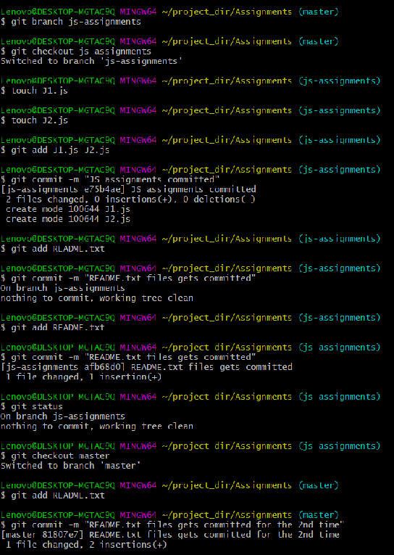

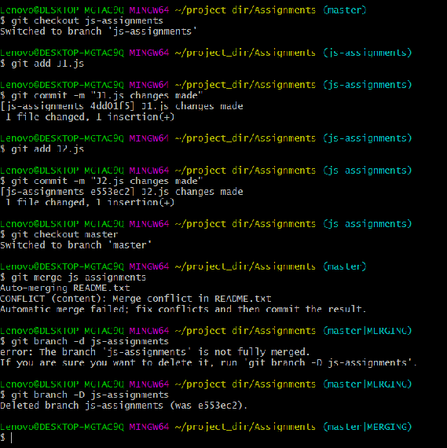

**GIT REMOTING:**

**SECTION🡪3:**

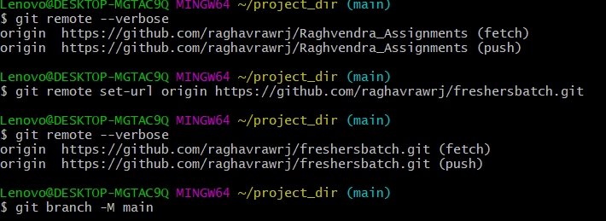

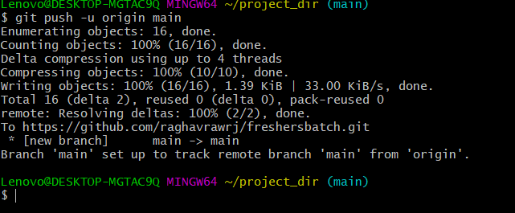

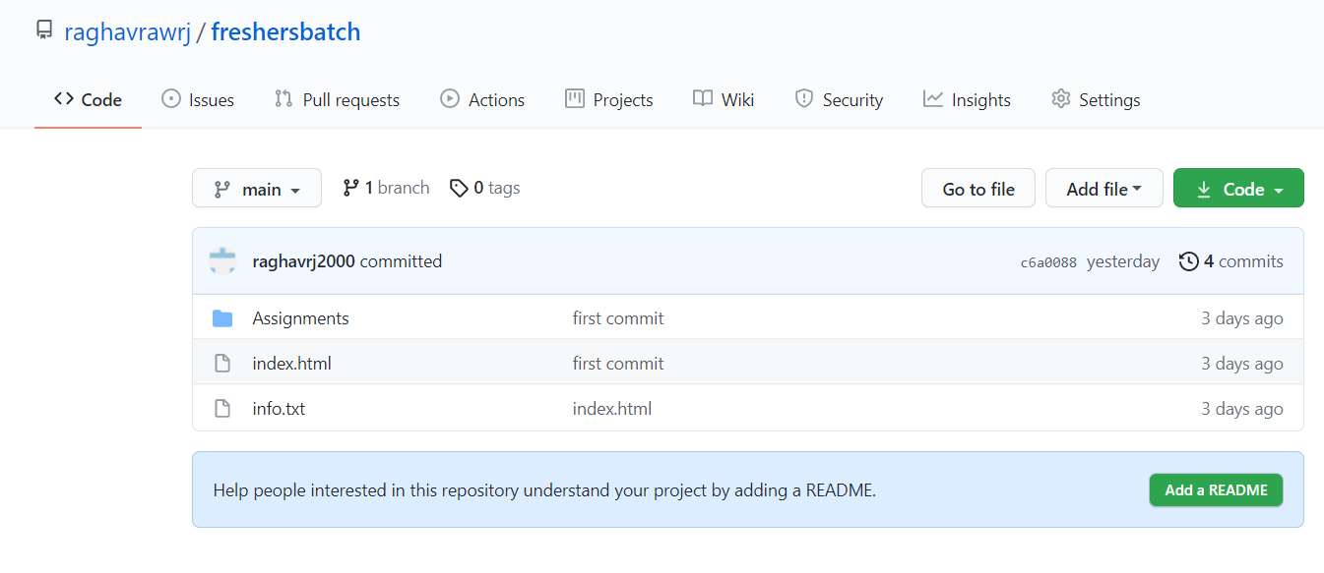

**SECTION🡪4:**

**(Pushing source code to remote repository using Eclipse GIT plugin) – Steps**

**to follow.**

1. One developer from project team will create eclipse projects SampleProj & add sample source code files. Then commit all files through eclipse GIT plugin.

2. Collaborate other team members with your github account so that they can also modify the committed files

3. Other developers from same team will checkout all files from remote repository. This might get conflicts since certain files fail to merge. In such case, merge it manually.

4. Commit & push the "SampleProj' project.